ALL PATIENT INFORMATION WILL REMAIN CONFIDENTIAL, REPORTER INFORMATION WILL BE DESTROYED

A
D
V
E
R
S
E

D
R
U
G

R
E
A
C
T
I
O
N

R
E
P
O
R
T

F
O
R
M

Before you start reporting please check which sections should be filled in
Please complete as much information as possible
Tick boxes where appropriate

Are you reporting an adverse drug reaction? (fill in sections 1 and 3)

Are you reporting an adverse drug reaction due to a medication error or other causative event (eg occupational exposure, abuse, overdose)? (fill in sections 1, 2 and 3)

Are you reporting a medication error or other causative event that did not lead to an adverse drug reaction? (fill in sections 2 and 3)
For a detailed explanation on how to fill in particular sections, please refer to the instructions at the back of the form
Section 1: Reporting Adverse Drug Reactions

PATIENT DETAILS

INITIALS MALE FEMALE AGE (at time of reaction) WEIGHT (in kg, if known) RACE AREA

1.2 SUSPECTED MEDICINE(S) / VACCINE(S) / BLOOD PRODUCT(S) / CANNABIS FOR MEDICINAL AND RESEARCH PURPOSES
(list the medicine you think caused the side effect)

Trade name, Active ingredient, Strength, Form, Batch no. Dosage, frequency, route Prescribed for Date started Date stopped
Medicine 1 |  |  | dd | mm | yr |  | dd | mm | yr
Medicine 2
Medicine 3

1.3 SUSPECTED ADVERSE DRUG REACTION (Describe each side-effect in as much detail as possible) Date started Date stopped
ADR 1 | dd | mm | yr |  | dd | mm | yr
ADR 2
ADR 3

1.4 LIST OTHER MEDICINES BEING TAKEN BY THE PATIENT (including over the counter & herbal medicinal products)

Trade name, Active Ingredient Dosage (amount), frequency (eg: twice a day), route (eg: oral) Prescribed for Date started Date stopped
 |  |  | dd | mm | yr |  | dd | mm | yr

Tick boxes where appropriate
1.5 How serious do you consider this Adverse Drug Reaction? 1.6 Outcome from Adverse Drug Reaction: 1.7 For this Adverse Drug Reaction(s):
ADR 1 ADR 2 ADR 3 ADR 1 ADR 2 ADR 3 YES NO
Fatal Recovered Suspect medicine 1 was stopped
Life threatening Recovering Suspect medicine 2 was stopped
Caused or prolonged Symptoms Suspect medicine 3 was stopped
hospitalisation continuing Was medicine restarted
Birth defect Long-term effects Manufacturer notified of this ADR
Caused disability Death Treatment required for this ADR
Other medically Not known If yes, which
significant condition Is this the first time you reported the ADR ________________________
Not Serious

1.8 ADDITIONAL RELEVANT INFORMATION (if known)
(known allergies, test results, medical history, discharge summaries – information may be attached)

Liver disease  Kidney disease | Allergy (please describe): | Pregnancy weeks
Other illnesses (please describe):

  - Was this ADverse drug reaction caused by a medication error or other CausATIVE EVENT?
Yes - please fill in section 2 and 3. No - please fill in Section 3 Reporter Details

M
E
D
I
C
A
T
I
O
N

E
R
R
O
R

R
E
P
O
R
T

F
O
R
M

SECTION 2: MEDICATION ERROR REPORTING
IMPORTANT: ‘The submission of a report does not constitute an admission that the patient, medical personnel, user facility, importer, distributor, manufacturer or the medicine itself caused or contributed to the event’.

  - MEDICINE(S) INVOLVED IN MEDICATION ERROR OR other causATIVE EVENT (eg Occupational exposure)
 | Medicine 1 | Medicine 2 | Medicine 3
If the same details were filled in section 1.2, you can leave this section blank
Medicine Trade Name
Active Ingredient (substance in a medicine that is biologically active)
Form (eg: tablets, injection)
Strength (eg: g, mg, ug)
Dose frequency, duration, route (eg: 1 tablet, 3 dly, by mouth)
Type of container (eg blister pack, loose strip or other)
2.2 DATE OF EVENT
Date event occurred: ___/____/____ Date event was detected: _____/____/____
2.3 DESCRIBE THE MEDICATION ERROR OR OTHER CAUSATIVE EVENT (eg OCCUPATIONAL exposure) RELATED TO THE MEDICINE
Free Text (eg Wrong route; wrong dose; wrong medicine; other): | For medication errors – tick the stage the error may have occurred  Prescribing  Dispensing  Preparation  Storage  Distribution  Administration

2.4 LOCATION WHERE THE EVENT OCCURED
(eg Nursing home, Home, Hospital, Pharmacy, Clinic, Other)

2.5 SUSPECTED CAUSE OF THE MEDICATION ERROR OR OTHER CAUSATIVE EVENT RELATED TO THE MEDICINE

2.6 ANY FACTORS CONTRIBUTING TO THE MEDICATION ERROR OR OTHER CAUSATIVE EVENT RELATED TO THE MEDICINE
(eg. Omission of meals, concomitant alcohol intake, over exposure to heat and sun, other)

2.7 WAS THE MEDICATION ERROR OR OTHER CAUSATIVE EVENT PREVENTABLE? Yes No

2.8 WAS ANY REMEDIAL ACTION RELATED TO THE MEDICINE TAKEN?
Yes (please describe)_________________________________________________________________________________ No

2.9 Recommendations to prevent repeat incident

2.10 DID THE MEDICATION ERROR OR OTHER CAUSATIVE EVENT RESULT IN AN ADVERSE DRUG REACTION?
Yes - please fill in section 1. No - please fill in your details below
----------------------------------------------------------------------------------------------------------------------------------------------------------------------------------------------------
SECTION 3: Reporter Details
Details will be destroyed following transmission to the EU central side effect database Eudravigilance

Type/Circle - doctor/dentist/pharmacist/other healthcare professional/patient
Name:
Address:
Telephone/Mobile:
E-mail address:

Signature _______________________________ Date ________________________

The Medicines Authority thanks you for the time taken to fill in this form.  The reporting of Adverse Drug Reactions is an important process whereby Regulatory Authorities can learn more about the medicine and its uses and take appropriate action in order to protect and enhance public health | SUPPLY OF ADR REPORT CARDS IS REQUIRED  INFORMATION ABOUT OTHER ADRs IS REQUIRED

INSTRUCTIONS FOR REPORTING ADVERSE DRUG REACTIONS AND MEDICATION ERRORS OR OTHER CAUSATIVE EVENT

Terms and Definitions

Definition for Patients/users of medicines (consumers)

Side effects (also referred to as adverse drug reactions or adverse events) are those troublesome effects, symptoms or feelings that show up when you are using a medicine. When medicines are used incorrectly they are more likely to cause a side-effect.

For this reporting system a medication error is an event, related to how medicines were used, which affected or could have potentially affected a patient’s safety and caused or had the potential to cause that patient to experience a side-effect.

Definition for Healthcare Professionals

Adverse Drug Reaction (ADR): An ADR is a response to a medicinal product which is noxious and unintended. This includes side effects resulting from the authorised use of a medicinal product at normal doses, medication errors; off-label use and the misuse and abuse of medicinal products.

Medication error: For the scope of this reporting system, medication errors that require reporting to the Medicines Authority are those which are related to the use of medicinal products. The adopted definition of a medication error is: Any preventable event that may cause or lead to inappropriate medication use or patient harm while the medication is in control of the health-care professional, patient or consumer. (National Coordinating Council for Medication Error Reporting and Prevention).

Other Causative Events: include occupational exposure, abuse, overdose etc.

Section 1: Side Effect Reporting

1.1 Patient Details: Only initials must be used, never the whole name. The identity is kept in strict confidence by the Medicines Authority.

Age at time of event or date of birth: Provide information that is as accurate as possible. Enter the birth date, if known, or the age at the time the side-effect started. For age, indicate time units used (e.g., years, months and days).

Gender: Enter whether male or female. If the side-effect or medication error concerns a congenital anomaly (birth defect) report the gender of the child.

Weight: Indicate whether the weight is in kilograms or any other unit. If the exact weight is unknown, try and make the best estimate.

1.2 Suspected Medicine(s)/Vaccine(s)/Blood product(s): For these reports, a suspect medicine is one that you think was associated with the side effect, interaction or medication error. Use the trade name as marketed. If this is unknown, use the active ingredient and the manufacturers name if known.

Dose: Report the strength and form of the medicine in the appropriate units. The frequency of administration and the route of administration should be included in this field e.g. 500mg tablets, twice daily, orally (by mouth). For medication errors involving a wrong dose, write the dose that was used in error.

Prescribed for: Provide the reason (indication) for which the medicine was prescribed as accurately as possible.

Therapy dates: Provide the date when the medicine was started (or best estimate) and the date the medicine was stopped (or best estimate). If no dates are known, an estimated duration is acceptable (e.g. 6 months) or, if less than 1 day then duration is appropriate e.g. 1 dose or infused over 1 hour.

1.3 Suspected Adverse Drug Reaction(s): Describe the side effect in as much detail as possible, including a description of what happened and a summary of all relevant medical information. Example 1-- A hemorrhage from the use of too much anticoagulant (such as heparin) is a side effect caused by treatment.
Example 2 -- The common side effects of cancer treatment including fatigue, nausea, vomiting, decreased blood cell counts, hair loss, and mouth sores are instances of side effects that occur in addition to the desired anticancer effect.

Date of event: Provide the actual or best estimate of the date the side effect first started. If day is unknown, month and year are acceptable. If day and month are unknown, year is acceptable.

1.4 Other Medicines: Enter all other medicines (herbal, over the counter medicines) that were being used at the time of event but that there is no suspicion of involvement in the event. Be as complete as possible

1.5 How serious do you consider each Adverse Drug Reaction?: The seriousness of each Adverse Drug Reaction should be marked in the appropriate box within the table. The following outcomes: fatal, life-threatening, hospitalization, disability, birth defect and medically significant conditions are considered to be serious adverse drug reactions
Fatal – only mark this box if it is suspected that death was an outcome of the reaction to the medication.
Life-threatening – only mark this box if it is suspected that the patient was at substantial risk of dying as a result of the ADR
Hospitalisation - initial/prolonged – only mark this box if there is a suspicion that admission to hospital or prolongation of hospitalisation was a result of the ADR by the medicine.
Disability or Incapacity – only mark this box if the adverse reaction resulted in a disruption of a person’s ability to conduct normal life functions.
Birth defect – mark this box if you suspect that exposure to a medicine before conception or during pregnancy may have resulted in an adverse outcome in the child.
Medically significant condition – mark this box when the ADR was a hazard to the patient and may require medical or surgical intervention to prevent further outcomes.
Non serious - mark this box if the consequences of the ADRs were non-serious (ie none of the above).

1.6 Outcome for each Adverse Drug Reaction: The outcome for each Adverse Drug Reaction reported, should be marked in the related ADR box within the table (eg Adverse Drug Reaction 1 was headache and the outcome was recovered; the Adverse Drug Reaction 2 was rash and the outcome was Symptoms continuing).
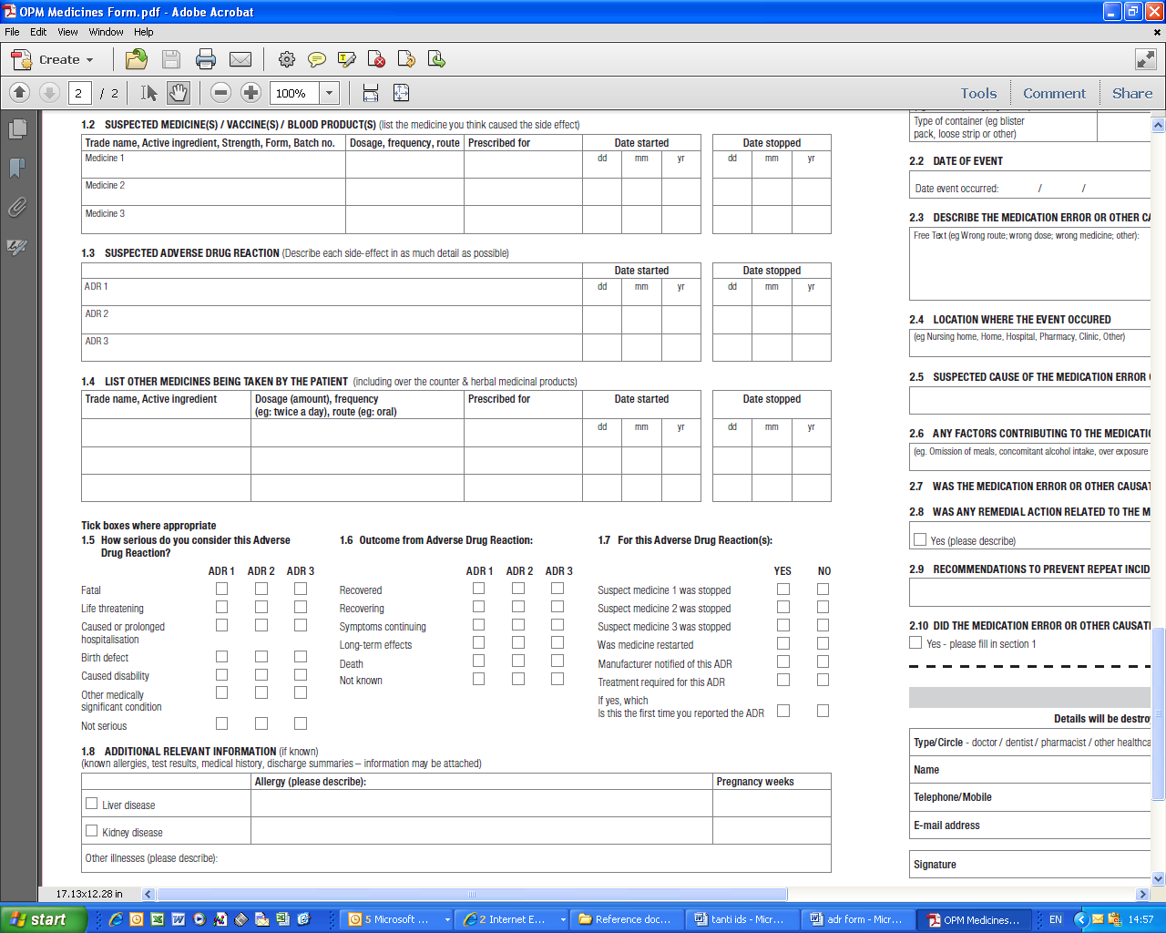
1.7 For this Adverse Drug Reaction: Fill in whether the Suspect medicine(s) indicated in field 1.2 were stopped. Was medicine restarted: indicate whether the patient was rechallenged. Was the manufacturer notified: Please check the appropriate box depending on whether the Marketing Authorisation Holder; the company that holds a license for the medicine – this information can be found on the box and the patient information leaflet) has been notified. Treatment required: indicate whether the adverse drug reaction needed to be treated and if yes, please describe.
Is this an initial report, Please check the appropriate box depending on whether this is the first report of this Adverse Drug Reaction, or whether this report includes additional/follow-up information to a previously submitted report.

1.8 Additional relevant information: Provide all appropriate information including medical history, negative test results, differential diagnosis, synopsis of any relevant pathology or further information on the course of events. If pregnant: in the case of a pregnancy please specify the number of weeks into the pregnancy at the time the ADR occurred.

1.9 Was this adverse drug reaction caused by a medication error or other causative event: Please tick applicable response and follow instructions within the form to report a complete incident report to the Medicines Authority

Section 2: Medication error reporting

A medication error may cause harm (an actual Adverse Drug Reaction) or may have the potential to cause a Adverse Drug Reaction. The Medicines Authority would like to hear about any type of medication error related to medicines, since it can be a source of knowledge on how medicinal products usage can be changed to minimise risk.

2.1 Medicines involved in medication error or other causative event (eg occupational exposure): Please provide the trade name as marketed. If this is unknown, use the active substance name with the manufacturers name if known. If the error involves look-alike or sound-alike medicine packaging, include detail on both products.

2.2 Date of event: Please indicate to the best of your ability, when the medication error occurred and the date when it was discovered.

2.3 Describe the medication error or other causative event related to the medicine: Described the medication error and the events that were related to it, in as much detail as possible, including a description of what happened, how the error was discovered, and who was involved (in a general way without identifying people).

2.4 Location where the event occurred: please describe the place where the event (medication error or other cause event) occurred like for example at home or at a pharmacy etc.

2.5 Suspected cause of medication error or other causative event related to the medicine: Describe the suspected cause(s) in as much detail as possible. Some examples of suspected causes are sound-alike and look-alike medication or packaging or instructions on dispensing bottles or package etc.

2.6 Any factors contributing to the medication error or other causative event related to the medicine: Describe the suspected contributing factor(s) in as much detail as possible (eg. whether there was any omission of meals, concomitant alcohol intake, over exposure to heat and sun etc.)

2.7 Was the medication error or other causative event preventable?: Tick the yes or no box in order to give your view on whether the medication error could have been prevented.

2.8 Was any remedial action related to the medicine taken?: Tick the yes or no box according to whether any action was taken to prevent the same error from occurring again. If action was taken please describe what this action was.

2.9 Recommendations to prevent repeat incident: If no action was taken, you can give your opinion on what remedial action could have been taken. If action was already taken and you would like to add to this, please insert your opinion in this box.

2.10 Did the medication error or other causative event result in a Adverse Drug Reaction?: If the medication error resulted in a Adverse Drug Reaction, section 1 on Adverse Drug Reactions should be filled in. If the medication error did not lead to an Adverse Drug Reaction, please fill in section 3 on reporter details.

Section 3.0 Reporter details,

Please provide the name, electronic address and/or mailing address and telephone number. Indicate whether you are a healthcare professional, or consumer/patient by circling the appropriate listing. All reporter information will be destroyed once the ADR is reported to Eudravigilance (a central EU database used by EU regulators to identify risks associated with medicines).

Submit electronically to the Medicines Authority postlicensing.medicinesauthority@gov.mt

